Name: Date:
US HISTORY 8
“COLD WAR HOTPOINTS”

- The Berlin Wall
https://www.youtube.com/watch?v=A9fQPzZ1-hg&t=59s

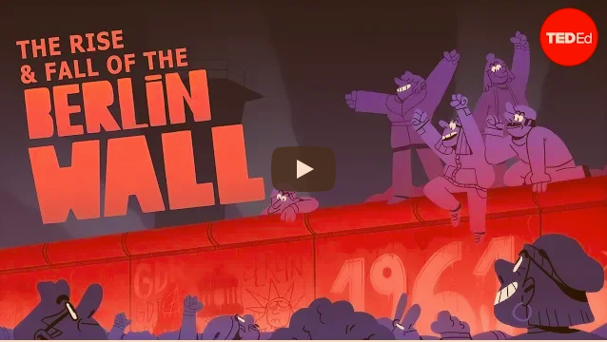
Finish the statements…
The Berlin Wall was built to…

East Germans wanted to leave during this time to…

The Wall fell because…

Answer in full sentences:
Compare the economies and environments of West and East Germany during the time when the Berlin Wall was in place.

- The Cuban Missile Crisis
https://www.youtube.com/watch?v=bwWW3sbk4EU&t=2s
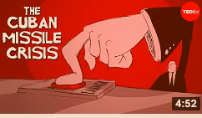
Finish the Statements…
The Cuban Missile Crisis is when the United States reached DEFCON….

The negotiations at the end of the Crisis were negotiated on November 27th by…

Answer in Full Sentences:
What were the options presented to President Kennedy to end the crisis?

How does the Cuban Missile Crisis show that “Cooler heads prevailed?”

Some historians disagree about Khrushchev’s intentions when placing the missiles in Cuba. Do you believe that the missiles were placed there for defensive or offensive purposes? Explain-

- The Space Race
https://www.youtube.com/watch?v=FxpC-8f--xo&t=26s
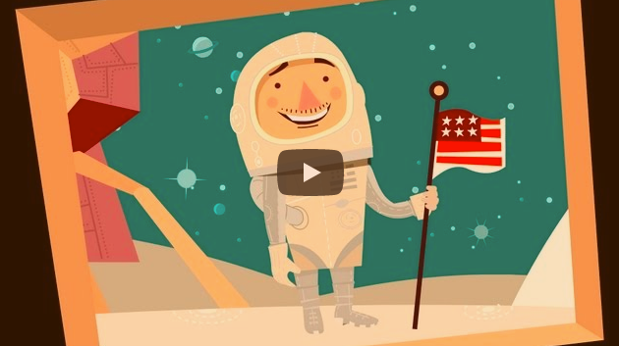
Finish the Statements…
On October 4, 1957….

When Sputnik launched the President of the United States was…

Answer in Full Sentences:
What are some of the advancements due to the Space Program?

- The Red Scare- McCarthyism
https://www.youtube.com/watch?v=N35IugBYH04
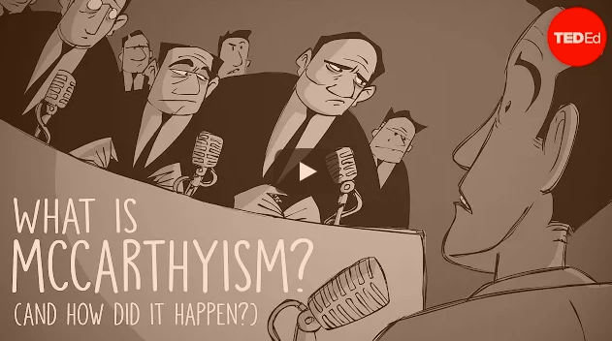
Finish the Statements…
The goal of McCarthyism was to…

The era of McCarthyism lasted…

Answer in Full Sentences:
Which organization run by J. Edgar Hoover sought to hunt down and eliminate communists from any position of influence in society?

Failure to testify before the House Un-American Activities Committee could have resulted in being:

It is the 1950’s in the United States. You are suspected of being a Communist. What are some of your “characteristics?”

Why did government officials knowingly not oppose McCarthyism? What was result?

- Political Cartoon: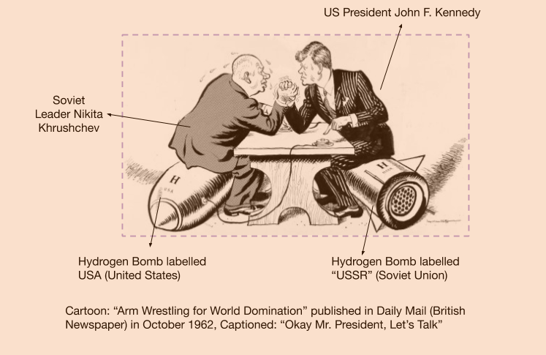

Which event of the Cold War do you think this image represents?

Identify and explain the use of two symbols by the cartoonist to depict tensions in the nuclear arms race of the Cold War?

