Death Penalty

Jake Reyes
5/27/15
Belief Systems
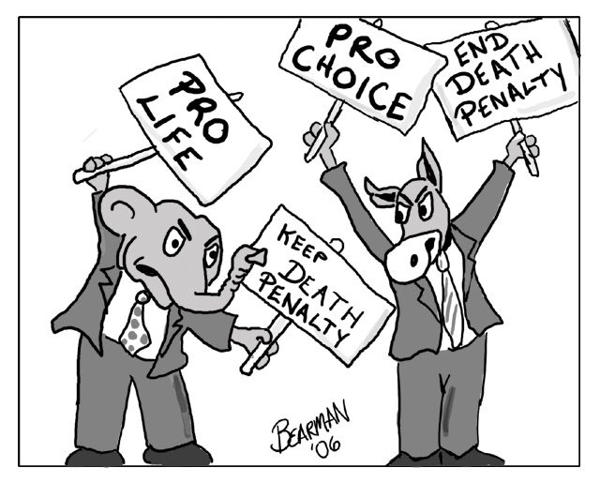

Is your opinion of the death penalty affected by what your religious view is?

Time Line

1622 The first legal execution of a criminal in the American Colonies occurs in Virginia with the execution of Daniel Frank for Theft.
1791 The Bill of Rights is ratified, including the Eighth Amendment, which prohibits the imposition of cruel and unusual punishments. Nevertheless, the practice of capital punishment is universally accepted and it is understood at the time that the Eighth Amendment was not intended to stop it.
1846 Michigan is the first state to abolish the death penalty. (except for treason, which was finally eliminated in 1963). Rhode Island follows in 1852, and Wisconsin in 1853.
1888 New York becomes the first state to adopt electrocution as an execution method following demonstrations of the new technology by Thomas Edison. Murderer William Kemmler is the first person executed in the electric chair on August 6, 1890 at New York's Auburn Prison.
1924 Nevada is the first state to adopt lethal gas as an execution method, following the use of poisonous gas in WWI, and executes Gee Jon for murder in a specially designed chamber.
1977 Oklahoma is the first state to adopt lethal injection as a method of execution.
2000 Florida death row inmate Frank Lee Smith, who died of cancer after 14 years on death row, is posthumously cleared by DNA testing in the 1985 rape and murder of an 8-year-old girl which sent him there. Nine other death row inmates across the country have been exonerated because of DNA testing, according to the Innocence Project, a New York-based group that has provided legal assistance to prisoners.

Definitions

Death Penalty- the punishment of execution, administered to someone legally convicted of a capital crime.

Capital Punishment- the legally authorized killing of someone as punishment for a crime.

Lethal Injection- an injection administered for the purposes of euthanasia or as a means of capital punishment.

Electrocution- is death caused by electric shock, either accidental or deliberate. The word is derived from "electro" and "execution", but it is also used for accidental death.

Posthumously- is an adverb that helps describe something that happens to a person after they die.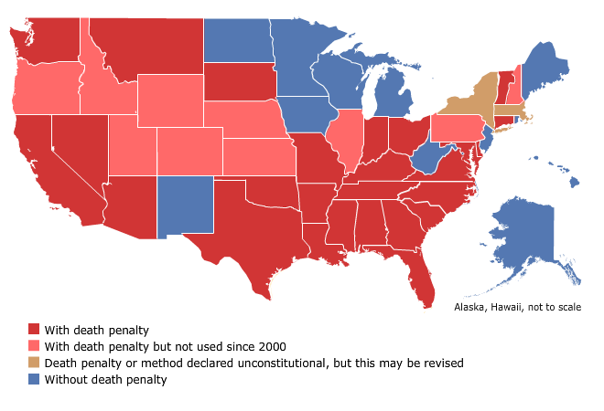

Not so “Fun Facts”

32 states allow the death penalty. On May 2, 2013, Maryland became the latest state to outlaw capital punishment, joining 17 other states and the District of Columbia.

46 death sentences were handed down in 2010, the lowest number of deaths since the death penalty was reinstated in the US in 1976. The previous record was 52 in 2009. Texas led all states with 17 executions in 2010.

New Hampshire and Washington are the only states which authorize hanging as a method of execution (as of Sep. 12, 2011). New Hampshire authorizes hanging as a method of execution if lethal injection cannot be used.

California executed its oldest death row inmate, Clarence Ray Allen, minutes after his 76th birthday on Jan. 17, 2006. The convicted murderer was blind and wheelchair-bound at the time of his execution.

Articles on the Death Penalty
http://www.usnews.com/opinion/articles/2014/09/29/the-death-penalty-saves-lives-by-deterring-crime
Pro-Con Chart
Pros | Cons
“If they do something really bad then yeah it’s fine, an eye for an eye.” – Cali Carano  “Yeah if they do something that is that bad, if someone kills another person.” – Matt Budano  “For the death penalty, the sole purpose of prison is rehabilitation of criminals and spending life in prison is useless and a waste of money.”  - Tim Chizzic  “I think that the death penalty should be allowed for certain crimes, if you have killed and done crimes that you have a life sentence for and caused harm to others I think death penalty should be allowed.” – Alee Cash | “Against because something shouldn’t be done to a person that’s so bad after what they did they should just have a bad consequence instead of something like dead.” – Elizabeth Selca  “Against because if someone does something bad it makes sense for them to go to jail for the rest of their life and suffer there.” – Joanna Pelc  “No because no one has the right to take away someone’s life.” – Noah Kelvas

Catholicism- The Catechism of the Catholic Church holdsthat if non-lethal methods are sufficient for preventing a criminal from doing further harm, then those methods should be preferred over lethal punishment.
Judaism- Mishnah (Sanhedrin 1:4) the death penalty could only be inflicted, after trial, by a Sanhedrin composed of twenty-three judges and there were four types of death penalty
Muslims- Muslims believe that capital punishment is a most severe sentence but one that may be commanded by a court for crimes of suitable severity. While there may be more profound punishment at the hands of God, there is also room for an earthly punishment.

Video Link
http://youtu.be/TVMho2cp1NE

Poll Link
https://www.polleverywhere.com/multiple_choice_polls/WmlFnQoivgZWxds

