Name:
Belief Systems- Buddhism

The Buddha Stressed the 4 Noble Truths:
- Everyone suffers
- Suffering is caused by desire
- To end suffering you must end desire
- To end desire you must follow the Eightfold Path
He realized this was challenging…so he added the Eightfold Path: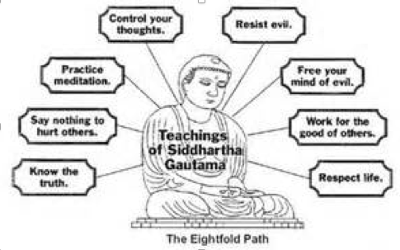

What would you identify as your most selfish desire? Explain-

Do you believe that giving up this selfish desire would make you more happy? Explain-

Read the article “What Tibetan Buddhism can teach us about Happiness”. (Linked on site)
2 Paragraphs
- Summarize
- Opinion

Your Article Review:

Belief Systems Movie- Groundhog Day
Is this movie an allegory for Buddhism, or is it simply a fun, silly movie about a strange holiday here in the United States? Explain

Cite 3 scenes that help you prove this:

Scene #1: Approximate Time:
Describe- How it shows your claim:

Scene #2: Approximate Time:
Describe- How it shows your claim:

Scene #3: Approximate Time:
Describe- How it shows your claim:

