Name:
PIG

Part I. How does Impeachment work?
https://www.youtube.com/watch?v=hSszixvo7d8
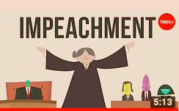

What does impeachment mean?
ARemoval from office
BConviction of a crime
CFormal accusation of wrongdoing

Who can formally initiate the impeachment process?
AThe House of Representatives
BAny citizen of the United States
CThe President

Where does the impeachment trial take place?
AThe White House
BThe Senate
CThe Supreme Court

How many votes are required for conviction of a president or vice president?
AA simple majority
BA unanimous vote
CA supermajority

Which of the following presidents was NOT formally impeached?
AAndrew Johnson
BRichard Nixon
CBill Clinton

What are the grounds for impeachment, and how are they open to interpretation?

Part II.
See the two articles posted- “Sad day or scam” from the AP and “Trump may be willing to testify” from Reuters.
+ Look at the ABC News Poll results:

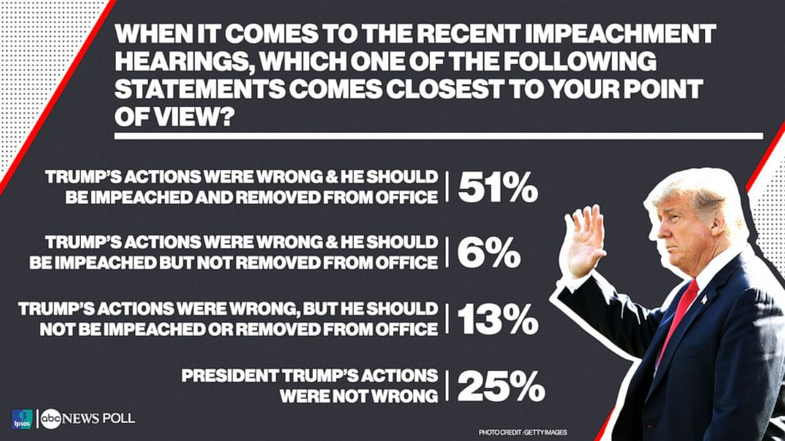

Take the Poll and defend your response:
https://docs.google.com/forms/d/e/1FAIpQLSfVb1JcKwwZSlu6UmOJDcUhwwMaLMpF42sN6OJjRz82OEim3g/viewform?usp=sf_link
Why? Use evidence to support your opinion:

