Name: Date:
History Through Film – Movie Posters Research
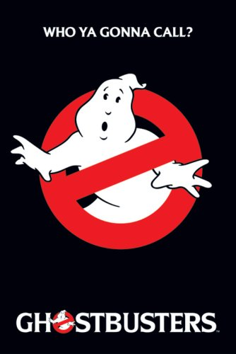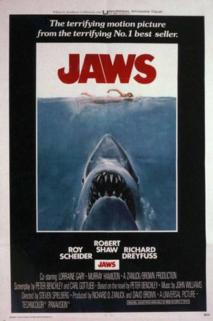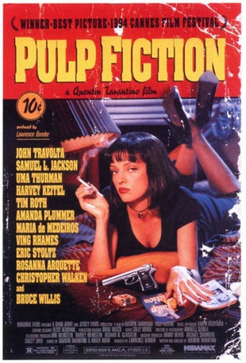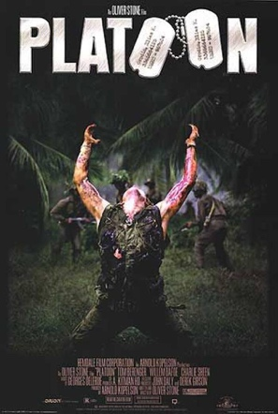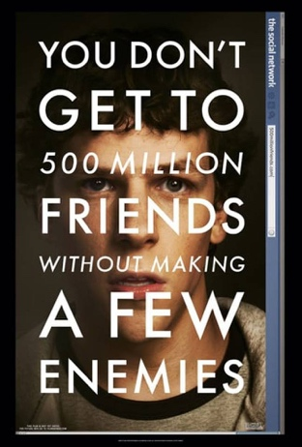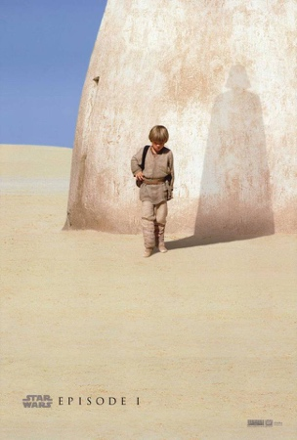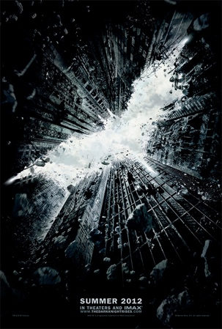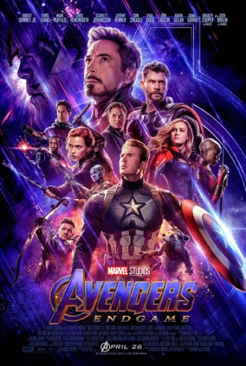
Watch “Movie Posters are all the same!”
https://www.youtube.com/watch?v=1ThnxSaExzU
What are 3-4 ways Movie Posters are all the same?

Watch the first 2:30 of “What the heck happened to Movie posters?”
https://www.youtube.com/watch?v=VXJiBkFgprQ
What are a couple complaints the narrator has with modern movie posters?

Movie “Taglines” - Look at the slideshow
http://www.shortlist.com/entertainment/films/the-40-greatest-movie-taglines-ever#
What is your favorite movie “tagline?”

What is your favorite Movie poster? (From the slideshows or not)
Describe or drag here:

What are some ideas for your movies “tagline?” Come up with 3-
(Just brainstorm taglines- Next class I will give you easy ways to make your poster!)

