PART 3–EXTENDED ESSAY
This question is based on the accompanying documents. The question is designed to test your ability to work with historical documents. Some of these documents have been edited for the purposes of this question. As you analyze the documents, take into account the source of each document and any point of view that may be presented in the document. Keep in mind that the language used in a document may reflect the historical context of the time in which it was written.

An enduring issue is a challenge or problem that has been debated or discussed across time. An enduring issue is one that many societies have attempted to address with varying degrees of success.

Task:

- Identify and define an enduring issue raised by this set of documents
- Using your knowledge of social studies and evidence from the documents, argue why the issue you selected is significant and how it has endured across time

In developing your answers to Part III, be sure to keep these explanations in mind:

Identify – means to put a name to; to name.

Define – means to explain features of a thing or concept so that it can be understood.

Argue – means to provide a series of statements that provide evidence and reasons to support a conclusion.

Guidelines:

In your essay, be sure to
- Identify the enduring issue based on a historically accurate interpretation of at least three documents.
- Define the issue using evidence from at least three documents
- Argue that this is a significant issue that has endured by showing:
  - How the issue has affected people or has been affected by people
  - How the issue has continued to be an issue or has changed over time
- Include outside information from your knowledge of social studies and include evidence from the documents

ENDURING ISSUE ESSAY
Directions: Read and analyze each of the five documents and write a well-organized essay that
includes an introduction, several paragraphs, and a conclusion. Support your response with
relevant facts, examples, and details based on your knowledge of social studies and evidence
from the documents.

Document 1
Trade and Knowledge
Among the most significant legacies of the Mongols was their concern with trade and their respect for knowledge. From the beginnings of the Mongol Empire, the Mongol Khans fostered trade and sponsored numerous caravans. The very size of the Mongol Empire encouraged the wider dissemination of goods and ideas throughout Eurasia, as merchants and others could now travel from one end of the empire to another with greater security, guaranteed by the Pax Mongolica.

[...]Yet as the Mongol Empire and its successors continued to disintegrate, the Pax Mongolica—which was never completely peaceful—collapsed. This led to the trade routes becoming insecure once more. In turn, this led to an increase of prices due to tariffs [taxes] and the cost of protection. The rise of the Ottoman Empire also impacted Italian merchants conducting business in the Black Sea and Eastern Mediterranean. With these restrictions, western desire for the luxury goods and spices of the east grew, encouraging an Age of Exploration. Beginning with Christopher Columbus, westerners began searching for new routes to China and India, particularly to the court of the Khan, even though a Mongol Khan had not sat on the throne since 1368. Thus, the Mongols indirectly led to European exploration and the intrusion of Europeans into Asia.
Source: “The Mongol Empire in World History” by Timothy May from North Georgia College and State University on World History Connected. http://worldhistoryconnected.press.illinois.edu/5.2/may.html

Document 2

Not only smallpox but measles, tuberculosis, diphtheria, whooping cough, and influenza arrived in the Americas with European conquistadors and colonists. Enslaved Africans brought malaria, yellow fever, and denge (breakbone fever), which thrived in the Caribbean and warmer parts of North America. Slave traders, in turn, carried yellow fever back to Europe, and European traders and explorers may have brought home syphilis from the Americas. Nowhere, though, did disease have the devastating impact it did in the New World. This was not the first time that a new disease had been introduced into a human population. In the 1300s, Mongol armies and traders from Central Asia brought the bubonic plague to Europe, and the resulting epidemic — the “Black Death” — killed one-third of the population of Western Europe. But even the Black Death can’t compare to the devastation of the indigenous peoples of North and South America. Hit by wave after wave of multiple diseases to which they had utterly no resistance, they died by the millions. Disease spread from the paths of explorers and the sites of colonization like a stain from a drop of ink on a paper towel.
Source: David Walbert, “Disease and Catastrophe.”
http://www.learnnc.org/lp/editions/nchist-twoworlds/1689. Creative Commons 2.5

Document 3

. . . Long-Term Effects. The trade in African slaves brought about the largest forced movement of people in history. It established the basis [reason] for black populations in the Caribbean and in North and South America. At the same time, it disrupted social and political life in Africa and opened the door for European colonization of the continent. . . . The shift [change] in European demand from gold, foodstuffs, and such products to slaves changed the relations among African groups and states. The prices Africans received for slaves made it more profitable for them to take captives [prisoners] from their neighbors than to establish [set up] networks for producing and selling other goods. In this way the slave trade encouraged strong states to raid [attack and steal from] weaker states for slaves. As a result, many African societies were torn by organized slave wars and general banditry [theft]. Successful slave-raiding and trading societies formed new states that were dominated [controlled] by military groups and constantly at war with their neighbors. . . .
Source: John Middleton, ed., Africa: An Encyclopedia for Students, Volume 4, Thomson Learning from the NYS Global History and Geography Regents Exam, August 2008.

Document 4a
Starting in the late 1800s and continuing in the mid 1900s, European nations, the United States, and Japan took over less powerful countries in Africa and Asia. This was called imperialism, sometimes referred to as colonialism. Imperialism is the domination by one country of the political, economic, and/or cultural life of another country or region. Countries or regions controlled by another country are called colonies. The process of dominating another country is called colonization.

Kwame Nkrumah was the first Prime Minister and President of Ghana, an African country that was colonized by the British until became independent in 1957.
. . . They were all rapacious [greedy]; they all subserved the needs of the subject lands to their own demands; they all circumscribed [limited] human rights and liberties; they all repressed and despoiled [violated], degraded and oppressed. They took our lands, our lives, our resources, and our dignity. Without exception, they left us nothing but our resentment, and later, our determination to be free and rise once more to the level of men and women who walk with their heads held high. . . .
Source: Kwame Nkrumah, Africa Must Unite, International Publishers, 1970 from the NYS Global History and Geography Regents Exam, January 2006.
Document 4b
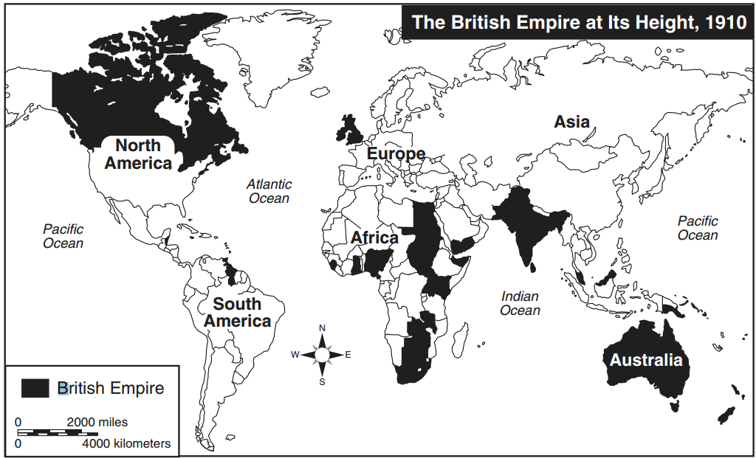
Source: Roger Beck and Linda Black et al., World History: Patterns of Interaction, McDougal Littell (adapted) from the NYS Global History and Geography Regents Exam, January 2003.
Document 5

Globalization is the process by which the world is becoming increasingly interconnected as a result of increased trade and cultural exchange.

Throughout most of human history, we have become more interconnected through trade and cultural diffusion, but since the mid-1900s the pace of globalization has increased rapidly. This is because of advancements in communication technology like the cellular phone and the internet, and improvements in shipping technology that have made it faster and less expensive to ship goods long distances.
McDonald’s Restaurants Around the World
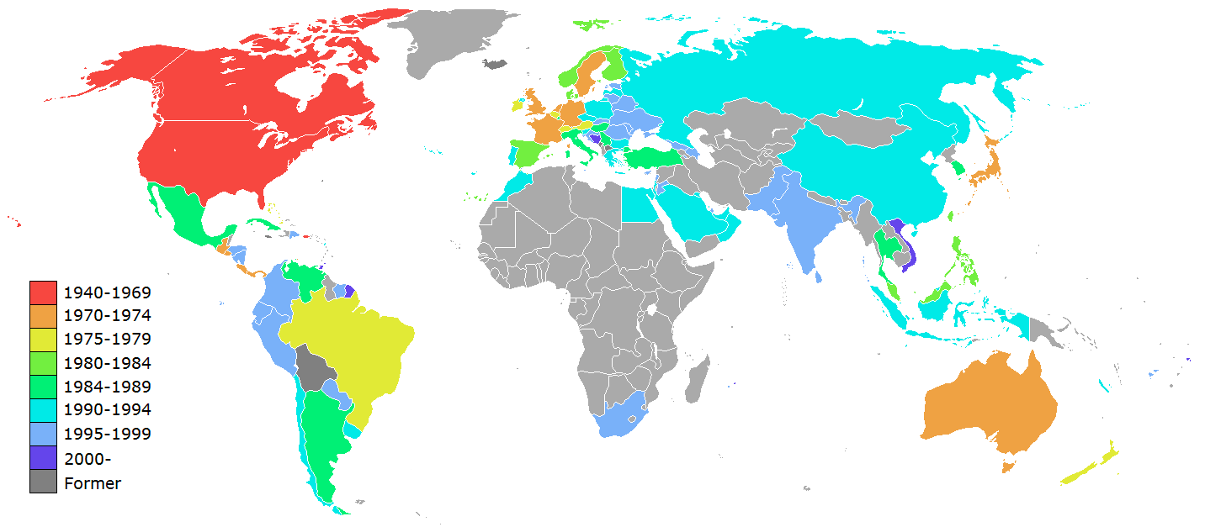
Source: https://upload.wikimedia.org/wikipedia/commons/0/08/Mcdonalds_World_locations_map.PNG

