Name: Date:
Belief Systems Period:

Non-Believers: Final Activities
Agnosticism
- An Agnostic is someone who neither believes nor disbelieves in the existence of God.
- The Belief in divinity is unknown or unknowable
Atheism
- An Atheist does not believe that God exists.
Theism
- A Theist believes that God does exist.

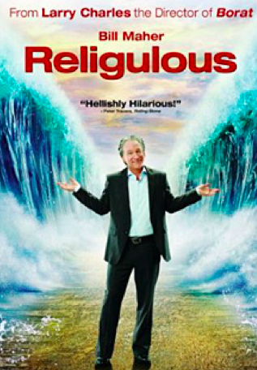
- Religulous- Clips

Does Bill Maher seem to be Atheist, Agnostic, or even Anti-Religion? Why?

What are 3 arguments he makes against organized religion and the belief in a God or Gods?

- Look at some famous Atheist symbols- http://www.religioustolerance.org/atheist6.htm
On the reverse of this handout please sketch a symbol you feel best would represent Atheism or Agnosticism:

