Name: Date:
Participation in Government Period:

FINAL EXAM GRADE- 20%!!!
PIG Grade Breakdown:
Quarter 1: 40%
Quarter 2: 40%
Final: (This video) 20%

www.studentcam.org/
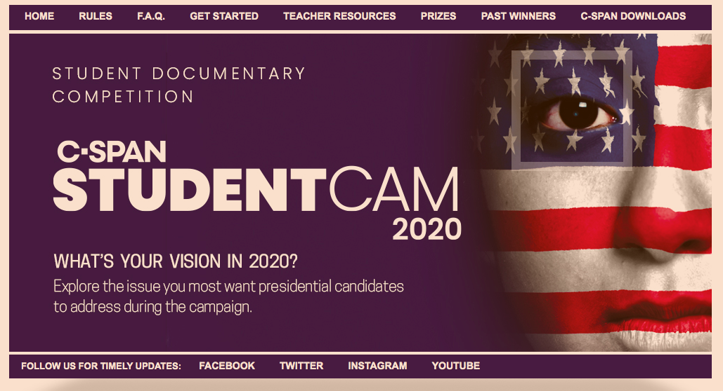

“What's Your Vision in 2020?”

Explore the issue you most want presidential candidates to address during the campaign.
Your video should analyze the current or historical significance of your chosen issue and include differing points of view.

StudentCam is C-SPAN's annual national video documentary competition that encourages students to think critically about issues that affect our communities and our nation.
This year students in grades 6-12 are asked to create a short (5-6 minute) video documentary on a topic related to the competition theme, "What's Your Vision in 2020? Explore the issue you most want presidential candidates to address during the campaign."
With cash prizes totaling $100,000 each year, C-SPAN awards prizes to 150 student documentaries, and over 50 teacher advisors. Since 2004, C-SPAN has awarded over $1 million dollars in cash prizes to past winning students and teachers.

For our class, we will follow StudentCam Competition Rules: Here

Important Dates:

- Friday December 20th- Kunze/Gibson Check in- 25 pts in 2nd quarter!
Students must hand in their completed StudentCam Research Outline. (Guideline attached)
- November 1 - January 20
Students may upload their completed documentaries and submit their entry form to CSPAN beginning on November 1.
- January 10th: PIG CLASS DUE DATE
Your video will be played in our class – Again, finished product will be 20% of course grade!
- Monday, January 20, 2020
The submission deadline for all entries in StudentCam 2020.
- Wednesday, March 11, 2020
The 150 prize winning videos will be announced on C-SPAN and on studentcam.org.

